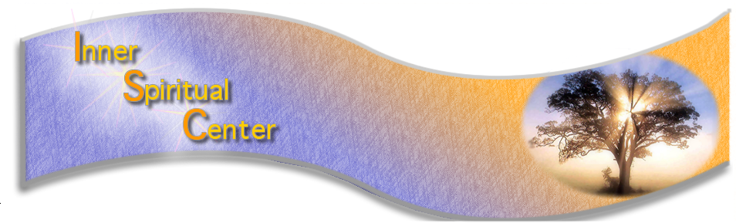
www.innerspiritualcenter.org info@innerspiritualcenter.org
333A Route 46 W Fairfield NJ # 255
INNER SPIRITUAL CENTER WELCOMES BACK VIA ZOOM
U.K. MEDIUM - DARREN BRITTAIN- OCTOBER 2021
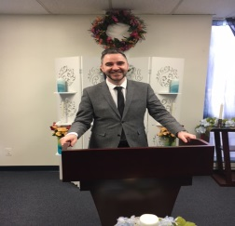

ZOOM CLASS_**Revealing the Evidential Levels of Mediumship**
Saturday 10/23 10 am – 5 pm $125.00
Class is best suited to those with some mediumship experience.
If you are skimming the surface of your mediumship and want to dig deeper for the richest evidence possible, this one-day class is the kick start you need. The clarity , quality, and depth of detail in the evidence from the Spirit World can facilitate the healing and understanding of continuity of life that mediumship can give, but the Medium needs to find it, mine it, and deliver it to its maximum potential.
Aims of this class are:
- Build confidence in your own connection to the spirit communicator and information
- *Learn to go deeper than the surface layer of evidence
- *Delivering this evidence in a deeper and more meaningful way
- *Looking at the influence of the rational mind on evidence presentation
- *Examining the benefits of both emotions and fact in the evidence process
- *Learning to allow Spirit to use the mediums experiences to enhance the evidence
- * Bringing it all together

ZOOM CLASS **Understanding of Trance Healing**
Sunday 10/24 1-4 pm $55.00 Pre- Registration only by 10/1 -Class is best suited for healers & mediums of all levels
Trance Healing is a form of mediumship which aims to allow a healing state beyond the influence of the medium’s mind
Aims of this class are:
*Understanding what trance mediumship is and what it is not
*Recognizing the differences in the altered states
*Understanding the process of trance healing
- Accessing the healing state experience
- * Working to understand and remove our own influence vs the spirit influence in the healing process
- -
- **Friday Evening Demonstration via ZOOM- October 22 7pm- 9:00 pm $30.00
- Spirit and You- A Demonstration of Spirit Communication and Messages with Darren Brittain. Dem and Q & A

**Private One-to-One Mediumship Tutorials via ZOOM Available
$125.00 60 minutes - Location Wayne (unless notified) - Email info@innerspiritualcenter.org for dates/times availability
Tutorials must be paid at time of booking.

(Bio info on back)

We are so happy to have back with the Inner Spiritual Center, Medium Darren Brittain. His love of Spirit, his humour and teaching techniques have gained him a new base of fans and students in the USA.
BIOGRAPHY
Darren walked into a Spiritualist Church at the age of 17 with the intention of going once and never again. What took him there was a desire to understand the 'lights' he had been seeing around people for the last 4 years which seemed to come on as a result of painful headaches that he had been having during that time. During that evening he joined in the open circle and watched various people (whom he admits to thinking at the time were all "mental"), talking to other people about their "granddad's rhubarb" and other such seemingly trivial pieces of information. He felt an urge to leave as it appeared that he wouldn't get any answers from what he had seen. It was at that point that a lady came over and proceeded to deliver a message to him about how psychic he appeared to be, how he 'saw' lights around people which she described as an aura, and how the Spirit World had work in store for him. She then made a prediction that within a year he would stand on the platform and do the work she did.
Since 1995 Darren has demonstrated his gift in Spiritualist churches, public halls and theatres. His gift has taken him to all counties in the UK as well as to Portugal, Spain, Gibraltar, Norway, Finland, Switzerland and Germany as well as offers of work from Iceland and the United States and Canada. He has written for, and been featured in several well respected esoteric publications including Two Worlds and Psychic News, and in the last couple of years has turned down three offers of work on high profile TV programmes, feeling that his work would be seen as purely entertainment and not for its true meaning.
In 2008 he took part in a Channel Four documentary about mediumship and was filmed demonstrating to an audience and delivering a private sitting to the presenter. Such is his accuracy, private tutorials and Mediumship assessments with Darren are in great demand and his public demonstrations often sell out well before the date of the demonstration. His style of teaching is personal and personable, and his strength and passion is helping the student to remove their own mind from the process of mediumship to give more attention to the Spirit World. He is able to convey messages from the other side; often with such accuracy there is no doubt that a world exists after this one. His reputation for delivering names, dates, street names, and personal information to identify loved ones has earned him a reputation as a medium of the high quality. As well as being able to convey messages from the Spirit World, he sees his work as much more than that. He has a desire to remind people through his own experiences of life, and through his connection to Spirit, that we are all Divine in origin and how we can attune to that source of love to help us to heal.
Darren also has a new book published this year- From Innocence to Inner Sense. Please check his website to order www.darrenbrittain.co.uk

